INSTITUTION ADMINISTRATION
& RECOMMENDATION SYSTEM

BY
Ali Rehman Khan k17-3808
Sameer Khowaja k17-3613
Muhammad Bilal Khan k17-3872

Instructor
Miss Tania Iram

Submission Date: 03-12-2019

Department of Computer Science

FAST-NU

Table of Contents

1. INTRODUCTION...............................................................................................................................5
1.1. Purpose of Document.........................................................................................................................5
1.2. Intended Audience .............................................................................................................................5
2. OVERALL SYSTEM DESCRIPTION ............................................................................................6
2.1. Project Background.............................................................................................................................6
2.2. Project Scope ......................................................................................................................................6
2.3. Not In Scope ........................................................................................................................................6
2.4. Project Objectives ...............................................................................................................................6
2.5. Stakeholders ........................................................................................................................................6
2.6. Operating Environment ......................................................................................................................6
2.7. System Constraints.............................................................................................................................6
2.8. Assumptions & Dependencies ..........................................................................................................6
3. EXTERNAL INTERFACE REQUIREMENTS.................................................................................7
3.1. Hardware Interfaces ...........................................................................................................................7
3.2. Software Interfaces .............................................................................................................................7
3.3. Communications Interfaces ...............................................................................................................7
4. FUNCTIONAL REQUIREMENTS......................................................................................................8
4.1. FUNCTIONAL HIERARCHY ........................................................................................................8
4.2. Use Cases............................................................................................................................................8
4.2.1. [Title of use case] ...........................................................................................................................8
5. NON-FUNCTIONAL REQUIREMENTS........................................................................................................................9
5.1. Performance Requirements...............................................................................................................9
5.2. Safety Requirements ..........................................................................................................................9
5.3. Security Requirements .......................................................................................................................9
5.4. User Documentation...........................................................................................................................9
SDS ..............................................................................................................................................10
6. SYSTEM ARCHITECTURE .............................................................................................................11
6.1. SYSTEM LEVEL ARCHITECTURE ...................................................................................11
7. DESIGN STRATEGY ....................................................................................................................11
8. DETAILED SYSTEM DESIGN......................................................................................................11
8.1. DATABASE DESIGN ....................................................................................................................11
8.2 . APPLICATION
DESIGN........................................................................................................................................12
9. REFERENCES ................................................................................................................................12
10. APPENDICES..............................................................................................................................12

- Introduction
  - Purpose of Document
The purpose of this document to explain what our project is supposed to do. It gives complete overview of the functionalities provided by our web application which provide ease for our application user. The motivation for this project is to help the under privileged students of rural areas by suggesting them the required resources other than their schools and helping them in understanding their topics well. Our customers are the institutions who want to automate their manual traditional system into advanced international system. Our system will also help parents in identifying the best school for their children.
1.2Intended Audience
1. Admin
2. Parent
3. Teacher
4. Student
1.2 Scope
This document is the only one that describes the requirements, design and implementation details of the system. It is meant for the use by the developers and will be the basis for validating the final delivered system. Any change made to the requirements in the future will have to go through a formal approval process. The developer is responsible for asking clarification, where necessary, and will not make any alteration without the permission of the client.
  - Definitions, Acronym, and Abbreviations
Institute: an organization having a particular purpose, especially one that is involved with science, education, or a specific profession.
Recommendation: a suggestion or proposal as to the best course of action, especially one put forward by an authoritative body.
1.4Document Convention
Font used is Times New Roman
Font Size used is 12, 14, 16

- Introduction
2.1Project Background
The Project is used by school administration. In the project school can do multiple functions and also users can recommendation an institute. Developer is responsible for: developing the system, hosting the software on the client’s hardware, conducting any user training that might be needed for using the system through soft copy of technical manual/report and presentation slides, and maintaining the system for a period of one year after the hosting and giving updates on new institutes open near client.
2.2Project Scope
Administrator:
The admin of the school deals with the staff, teacher and student registration and also configure them. He also check fees status of all students deals with the staff and teacher salary payment also manages the expense of schools which automatically calculates the profit or loss of the school. He can also make announcement which can be seen by teachers and students.
Student/Guardian:
Students can also access the web application. They can view their personal or Institutional information on the home page, check their marks according to the examination type, and check their attendance monthly basis. Guardians also have rights to access student account to view their children progress or can also pay fees using Authorize.Net feature.
Teacher:
Teacher can view their profile, make and view announcement, take and edit attendance, assigned marks to students.
2.3Not in Scope
We will work further on manual attendance function in future.

2.4Project Objective
Our objectives for this project are that user can login/signup to an Institute and then can perform multiple functionalities. They can get institute recommendation. There are typically two primary purposes for any school website. One is to provide timely, engaging, and current information to your current parents, students, staff, and community. The second purpose is to attract new students (through their parents or guardians) and to recruit quality staff.

2.5Stackholder
Admin -> Have all authorities.
Teacher -> Can Add delete update Announcement and resources.
Student -> Can view announcement and resources.
Parent -> Can view announcement and resources also can get recommendation.

2.6Operating Environment
- Hardware requirement is Computer with proper wifi connection on any windows and system. The system should run have any Window 32 or 64 bit, 250MB plus RAM, 40GB HDD. The most important is user should have internet access.
- Software requirement is browser (Chrome, firefox, etc).
2.7 Inputs and Outputs
User can be a teacher, student, parent or admin. They must have id and password for login else they need to sign up first. After login they can perform their respective functionalities.

2.7Operating Environment
- The system should run have any Window 32 or 64 bit, 250MB plus RAM, 40GB HDD. The most important is user should have internet access.
- Software requirement is browser (Chrome, firefox, etc).
- The main user of this system will be Parents, Student, Teacher, and Admin. Who are somewhat literate with computers and know what to do.
- Software constraints: Only those people can access the website functionalities who are related to school only.
- Hardware constraints: Only run on those devices which support web application.
- Cultural constraints: This website uses English language only.
- Legal constraints: Only those users can use the website whose id and password are provided by the admin.
- User constraints: people age >=3

2.9Assumptions and dependencies
- Internet should be available and server should be running properly

- External Interface Requirements
This website which we are building can be accessible by any one which have proper internet connection and connection on our server.

3.1Hardware Interface
- Computer as Server
- Computer as Client
- Node.js API for connection and data retrieval.

3.2Software Interface
- Tools used are HTML, CSS, JavaScript, JQuery, Bootstraps, node.js for GUI and connections
- Tools used for Database is Firebase
- Communication is done by client sending signal to server and data is retrieve through route calls and shown on his profile page.

3.3Communication Interface
- Not Applicable

4. Functional Requirements
4.1 Product Function Perspective
- The Teacher can assign marks to all the students according to the subjects and exams time also calculate the total marks and position holders. Students can view their marks which teacher assign to them.

- The Teacher and Admin can view and make announcements also upload attachment like exam schedule and class Time table. Student can only view announcements according to their class and sections which their teachers and admin makes.

- The Teacher and Admin can view and make classes, sections and can also add students in them.

- The students can respond to a particular resource as helpful or not-helpful.

- The Teacher and Admin can view and make notifications for specific class students. Student can only view notifications according to their class and sections which their teachers and admin makes.

- The Teacher and Admin can view and add resources also upload attachment like links and videos. Student can view and download resources according to their class and sections which their teachers and admin makes.

- The Admin can view and add Users Data. Student and Teachers can view their given data which admin makes.

- The Teacher and Admin can view and add tags on particular resource. Student can view and download resources according to their class and sections which their teachers and admin makes with the help of tags.

- The parents can provide their requirements and our system will recommend school for their children.

- The Teacher and Admin can view and make Homework for a specific class of students. Student can view homework according to their class and sections which their teachers and admin makes.
- The Admin have a right to update the registered staff and student information. Any changes needed to teacher’s bio can only be made through admin.

- The Teacher and Admin can view and store files. Student can view and download files according to their class and sections which their teachers and admin makes.
- The Teacher and Admin can view and make test for a specific class of students. Student can view test according to their class and sections which their teachers and admin makes.
4.2Use Cases
Use case Diagram
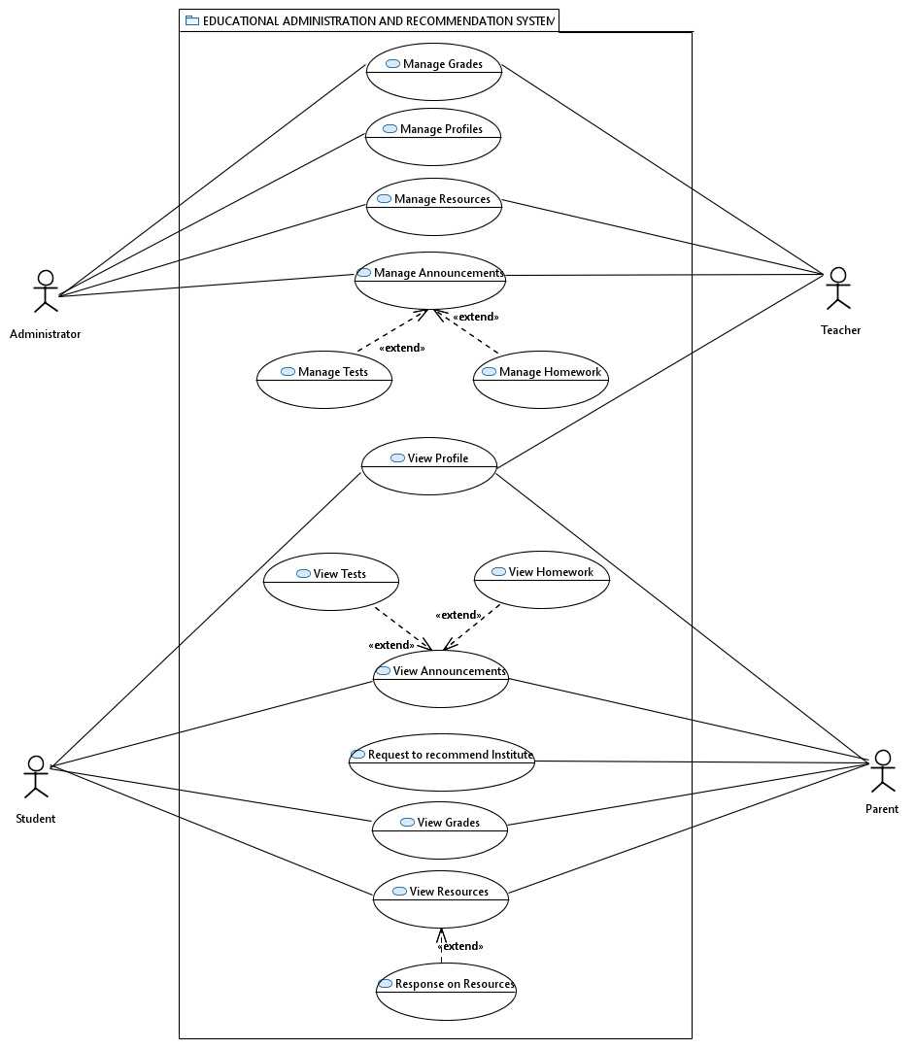
Use case Description
Use Case: Announcement
Actors: Student, Teacher, Admin
Description: The Teacher and Admin can view and make announcements also upload Attachment like exam schedule and class Time table. Student can only view announcements according to their class and sections which their teachers and admin makes.

Use Case: Digital Library
Actors: Student, Teacher, Admin
Description: The Teacher and Admin can view and add resources also upload attachment
Like links and videos. Student can view and download resources according to their class and sections which their teachers and admin makes.

Use Case: Manage Profile
Actors: Admin
Description: The Admin have a right to update the registered staff and student information. Any changes needed to teacher’s bio can only be made through admin.

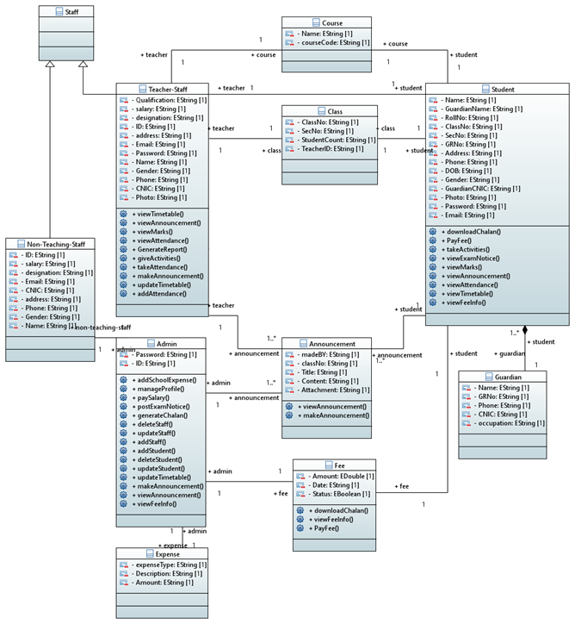

5. Non-Functional Requirements
5.1 Performance Requirements
The System is very high speed and feasible to the user, it is not a complex system it has a different section for every work so user can navigate through it easily which take very less time give a plus point of speed efficiency. This System is also secure, no user can access the personal info of any other user, for each and every work it maintain database and give a positive point of concurrency and provide concurrent data to user.

5.2 Safety Requirements
Not applicable

5.3 Security Requirements
Initially only the registered user can login the system whether it is a teacher student or Admin. It also validates all types of form whether user input valid details or not. The system is secure in all aspect.
5.4 User Documentation
Not applicable

6. Specific Requirements
6.1 System Architecture
The hierarchical overview of the system there are there section Admin, Teacher and Student each are working separately from each other some functionalities sharing the data between each other like Announcement can be viewed by all three actors and can only be made by Admin and Teacher. Similarly The Students can view marks which were assigned to them by teachers according to the subjects.
Except that all three portions (Admin, teacher, and student) works in isolation with each other’s.
6.2 System Level Architecture
6.2.1 System Implementation
We have used HTML for structure and CSS for design purpose, also we have used Bootstrap is used for responsive on our website. JavaScript is main language in our system plus we have used node.js as core for our backend function i.e. route calling and fetching data from Firebase Database.
The main requirement for client is that, they should have WIFI connected else website will not run because we have used FIREBASE for our database storage and Firebase works on internet.
6.2.2 System Verification & Testing
Designers need new verification and validation (V&V) technologies for systems that feature autonomy and safety criticality. We arm designers and developers with analysis and formal verification algorithms and tools. Our efforts push V&V activities earlier in the lifecycle. We champion the use of architectural model-based risk analysis throughout system development to increase confidence. We promote the use of virtual system integration practice to reduce costly rework before a system is deployed. By creating and prototyping formal V&V methods, we seek also to improve continuous runtime mission assurance.
6.2.3 Hardware and Software Platform description
- Hardware requirement is Computer with proper wifi connection.
- Software requirement is browser (Chrome, firefox, etc).
6.2.4 Tools used
- HTML - CSS - JavaScript and some JQuery
- Bootstrap - Node.js - Firebase and more

Deployment Diagram:
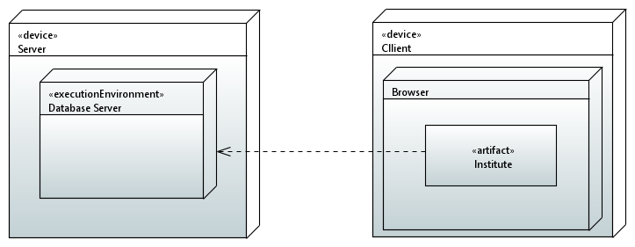

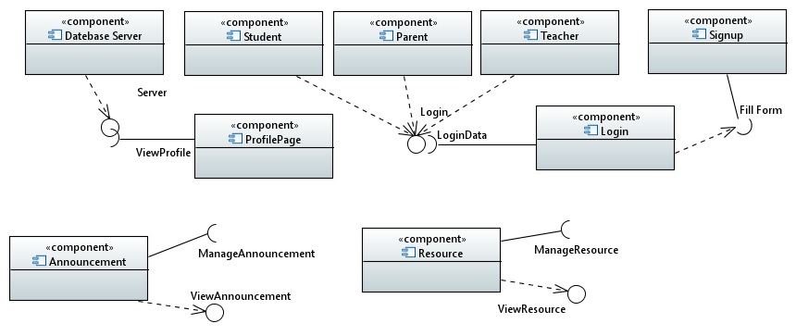

7. Design Strategy
Many different adaptations, tests, and experiments have been left for the future due to lack of time (i.e. the experiments with real data are usually very time consuming, requiring even days to finish a single run). Future work concerns deeper analysis of particular mechanisms, new proposals to try different methods, or simply curiosity. There are some ideas that I would have liked to try during the description and the development such as System more complex than FLEX and SLATE.
-To sum up our system is like Flex and Slate somehow but not implemented fully, by given more time we can build a fully hybrid system which will be powerful and fast.
-We can use AI to our system and make it better and cheaper.
-We can build mobile app and desktop app for our website for convenient.

8. Detailed System Design
8.1 Detail
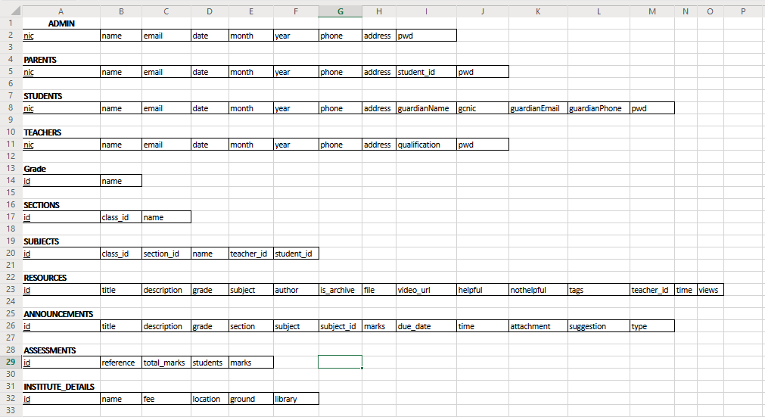

8.2 Creation of tables (SQL):
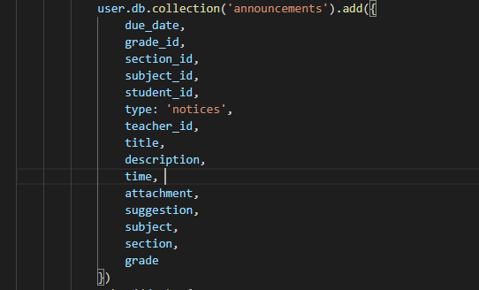
Table1 : announcements

Table2 : assessments
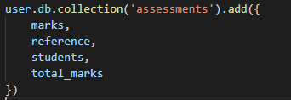

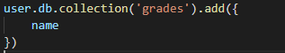
Table3 : grades

Table4 : institute_details
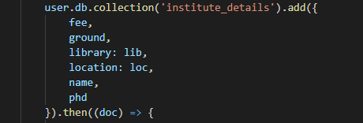
Table5 : admin
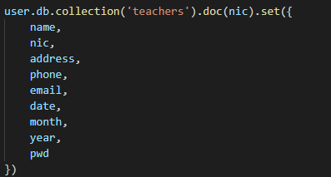
Table6 : parents
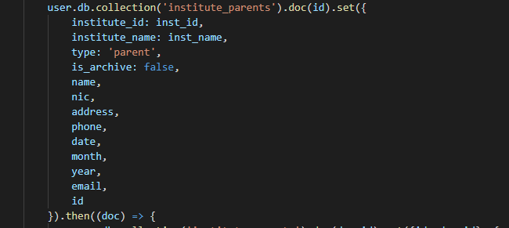
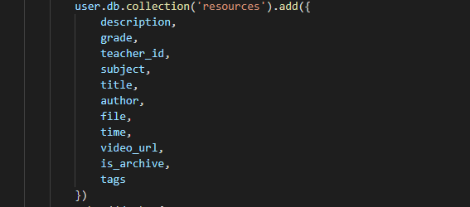
Table7 : resources

Table8 : sections
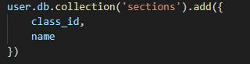

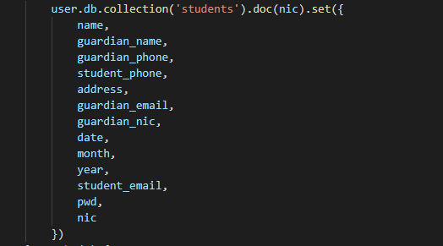
Table9 : students
Table10 : subjects
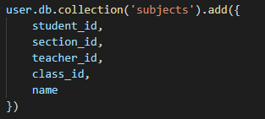

Table11 : teachers
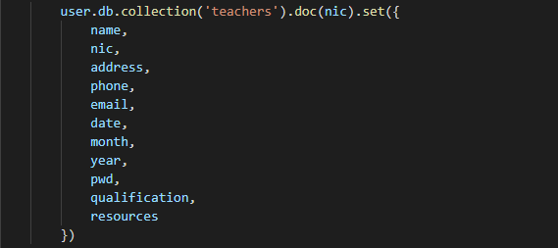

ER Model 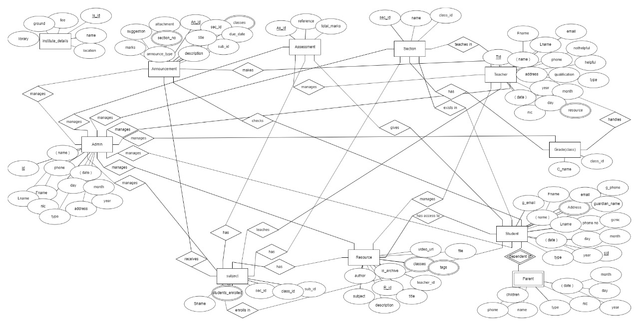

8.2 Application Design
8.2.1 Sequence Diagram
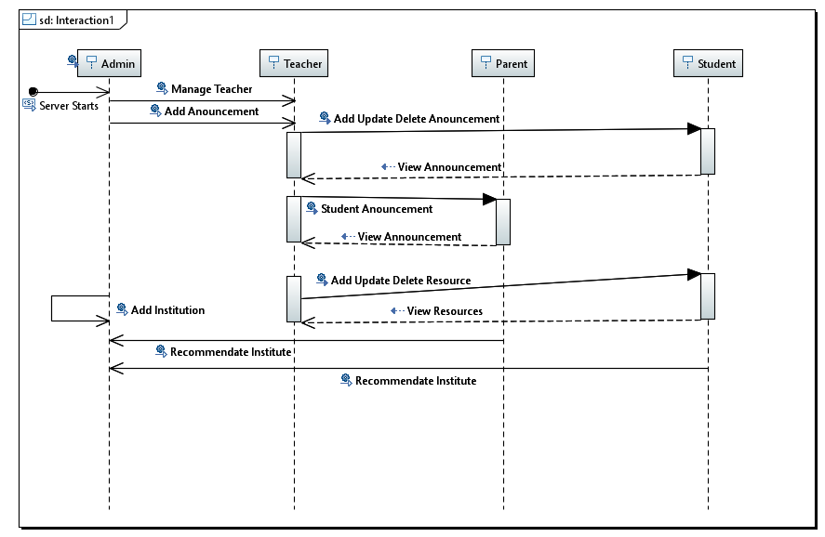

8.2.1 State Diagram
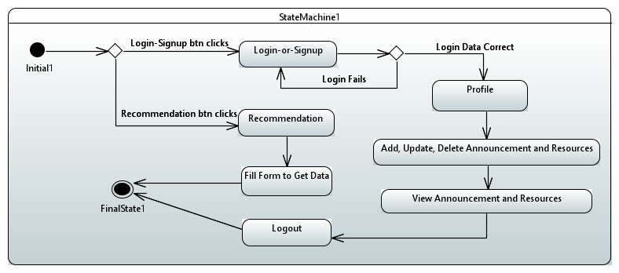

8.2.1 Activity Diagram
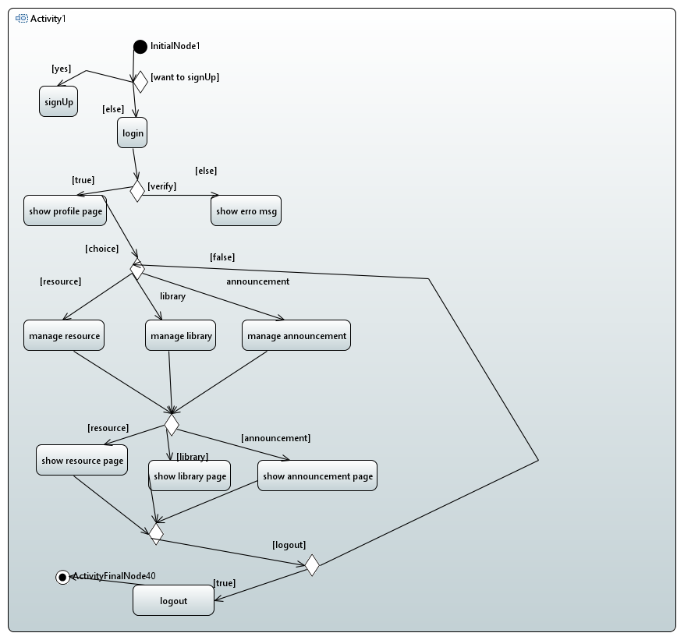

8.2.2 Conclusion
Administrator The admin of the school deals with the staff, teacher and student registration and also configure them. He can also make announcement which can be seen by teachers and students.
Student/Guardian Students can also access the web application. They can view their personal or Institutional information on the home pages; check their marks according to the examination type. Guardians also have rights to access student account to view their children progress feature.
Teacher can view their profile, make and view announcement, assigned marks to students.
The System is very high speed and feasible to the user, it is not a complex system it has a different section for every work so user can navigate through it easily which take very less time give a plus point of speed efficiency.

8.2.3 System Flow
- First user will be on home page of our website where there are two Btn i.e. Login and Registration and Recommendation.
- IF he clicks on Recommendation Btn then he will redirects to Institute Recommendation Page and IF he clicks. Login and Registration Btn he will redirects to Login and Registration Page.

* Login and Registration Page:
- IF Sign up Btn clicks and all Information Enter in form are filled correctly Then Sign up Successful and Data inserted in Database
ELSE there will be error of required Field if field is not filled.
- IF Login Btn clicks and Correct Information given Then User redirects to Profile Page.
- AFTER Login:
- Clicks on Announcement User can add Announcements if he is not student or parent but can view Announcements.
(Add Announcements can get error if field is not filled properly)
- Click on Resources User can add, delete, and update Resources if he is not student or parent but can view Resources.
(Add, delete and update Resources can get error if field is not filled properly)
- Library is where all Resources is kept and student or parent can view it.
- Grade button clicks shows all subjects’ announcements and information necessary for student.
ELSE user can’t Login if wrong information is provided.
- Logout Btn redirects user to Login Page.
(Page view is depends on who Login to System i.e. if he is Admin then full access is given, for student and parent and teacher access is given is less)

* Institute Recommendation Page:
- User will fill some fields to get recommended institute.
- He can redirect himself back to Home page by clicking Home Btn top of Recommendation page.
9. References
Not applicable
10. Appendices
Not Applicable

